

**Thank you for purchasing “Sharon’s Cozy Pet Warmer”!**

**We trust it gives you and your pet years of reliable service.**

Please read all instructions before using your new “Sharon’s Cozy Pet Warmer”.

**Caution:**

**“Sharon’s Cozy Pet Warmer” is not a device intended to heat water or other liquids**.

“Sharon’s Cozy Pet Warmer” should **not** be immersed in water; this action will result in damage to the product; can cause electrical shock, injury or death to the user and/or pet.

**Never operate “Sharon’s Cozy Pet Warmer” while the unit is disassembled.**

All safety devices in “Sharon’s Cozy Pet Warmer” are designed to protect the user and pets only while unit is fully assembled.

**As with all electrical devices, keep “Sharon’s Cozy Pet Warmer” out of reach of children.   
  
Reminder:**

The interior fan will cycle on and off as the thermostat reaches the defined parameters designed into the warmer.

Please allow 2 minutes for the patented interior heat chamber to reach its full operating temperature.

**Welcome!**

Now that you have purchased “Sharon’s Cozy Pet Warmer” from the KelsoStockwood Group Inc. the rest is easy. Simply plug the unit in to a polarized receptacle or extension cord. The warmer will turn on automatically and begin to operate. The temperature is preset, so there are no dials to adjust or settings to be made. The “Sharon’s Cozy Pet Warmer” temperature is factory adjusted to efficiently supply optimal heat and comfort safely to your pet.

The handle enables the user to easily place and move “Sharon’s Cozy Pet Warmer” wherever it may be needed. The convenient hook allows the user to hang “Sharon’s Cozy Pet Warmer” away from animals or debris without disturbing the stream of heated air for your pet.

In the event that the circuit breaker should trip on the “Sharon’s Cozy Pet Warmer”, the breaker can be reset simply by pushing the Reset Button on the end of the unit.

If the heating element should fail it can easily be replaced by following a minimal repair procedure. This is the only repair that should be done by the user of “Sharon’s Cozy Pet Warmer”. All other repairs should be completed only by properly trained and qualified personnel. For your own safety, **do not attempt to open the electronics end of “Sharon’s Cozy Pet Warmer”**. There are no owner serviceable parts in the area housing the electronic devices of “Sharon’s Cozy Pet Warmer”.

Opening the electronics end of “Sharon’s Cozy Pet Warmer” will void any and all warranties associated with “Sharon’s Cozy Pet Warmer.” There is a great danger of electrical shock as a result of opening the electronics end of “Sharon’s Cozy Pet Warmer” and bypassing of all the safety features built in to the device.

**Heating element replacement:**

**\*CAUTION*CAUTION\*** It is important to ensure the power is removed from “Sharon’s Cozy Pet Warmer” before any repairs are done. Please allow a **minimum** of 30 minutes cooling time before performing any maintenance actions to “Sharon’s Cozy Pet Warmer” to avoid possibility of severe burn.

**\*REMOVE THE POWER CORD FROM THE POWER SOURCE AT THIS TIME!\***

1. Loosen, but do not remove, the 2 screws on the retaining clips at the intake end of the pet warmer and move them to the side. (See Figure 1)

1. Remove the vented cover on the intake end of the pet warmer and let it hang down to the side of the warmer.

1. While pulling on the ring of the heating chamber remove approximately one half of the center heating chamber in order to expose the screws securing the vented end of the center heating chamber. (See Figure 2)

1. Remove the screw securing the vented end of the center heating chamber.

1. Remove the vented end of the center heating chamber and the heating element. (See Figure 3)

1. Remove and discard the heating element at this time. (See Figure 4)

1. Install a new, *Approved for Use* heating element at this time. Only *Approved for Use* heating elements should be used in “Sharon’s Cozy Pet Warmer”. Use of any other element will cause damage to the unit and void any and all warranties associated with “Sharon’s Cozy Pet Warmer”.

1. Reinstall the vented cover to the center heating unit and install the retaining screws.

1. Slide the center heating element back in to the outer chamber until the center heating unit reaches the inner stops of the outer chamber.

1. Reinstall the vented cover of the outer chamber and install the retaining screws.

Figure 1 (Removing Retaining Screws):

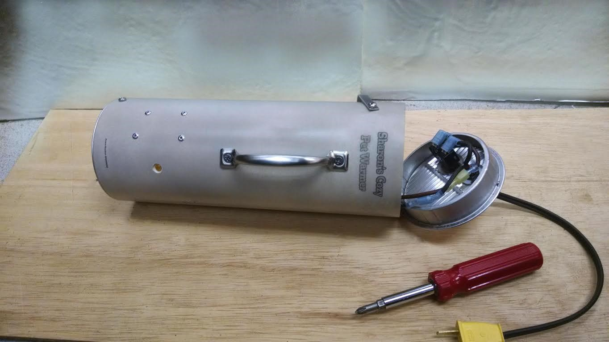

Figure 2 (Exposing Inner Chamber):

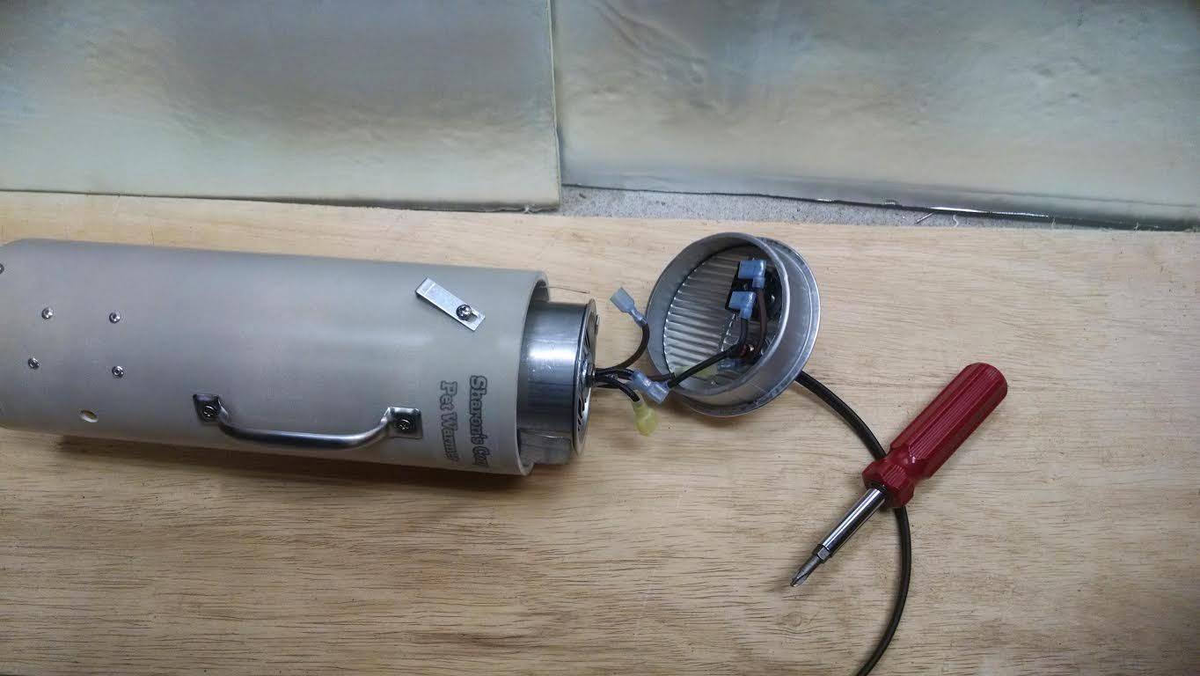

Figure 3 (Removing Inner Retaining Screw):

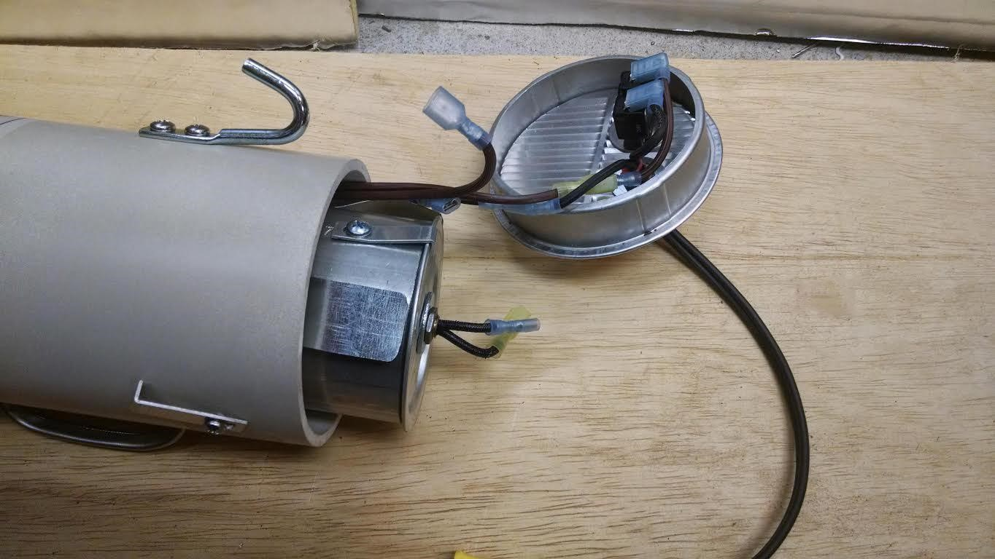

Figure 4 (Exposing and Replacing Heating Element):

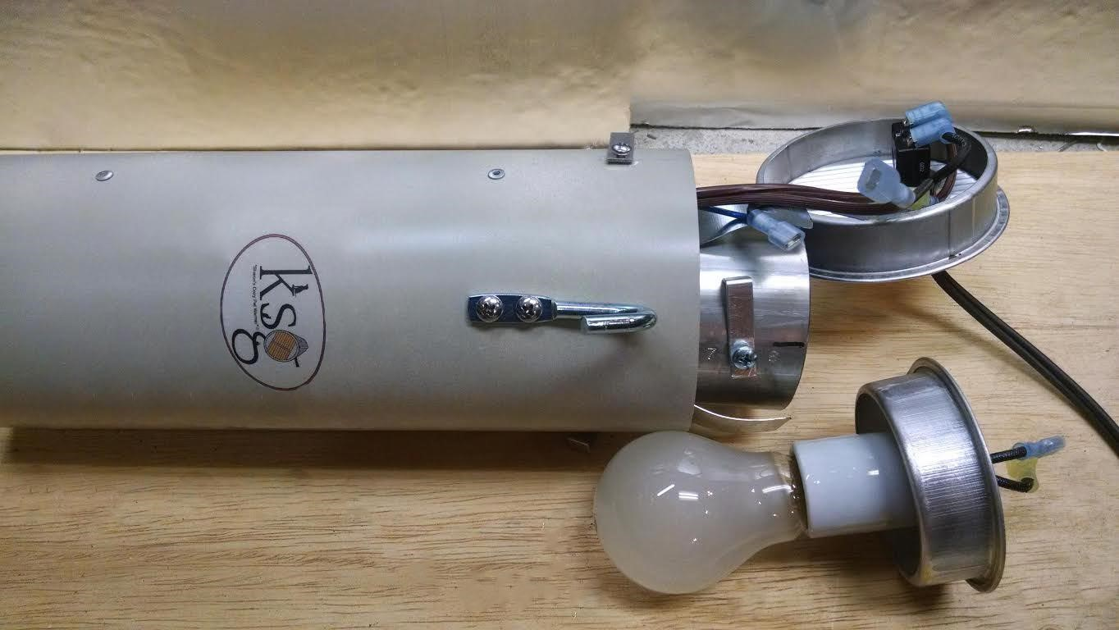

“Sharon’s Cozy Pet Warmer” is once again ready for use with your pet! Plug the unit in an electrical outlet, set the device at a desired location and allow the heated stream of air to warm and comfort your chilly pet. ***Reminder: “Sharon’s Cozy Pet Warmer” produces a temperature increase of 30° greater than the outside temperature entering the warmer. If the temperature outdoors is 0° or colder, please never leave your pets outdoors for any extended period of time.***

**\*\*PLEASE NOTE: The warm stream of air that exits “Sharon’s Cozy Pet Warmer” is opposite the hook. It is projected at a 45**° **angle. Please be sure to direct this end towards your pet.**

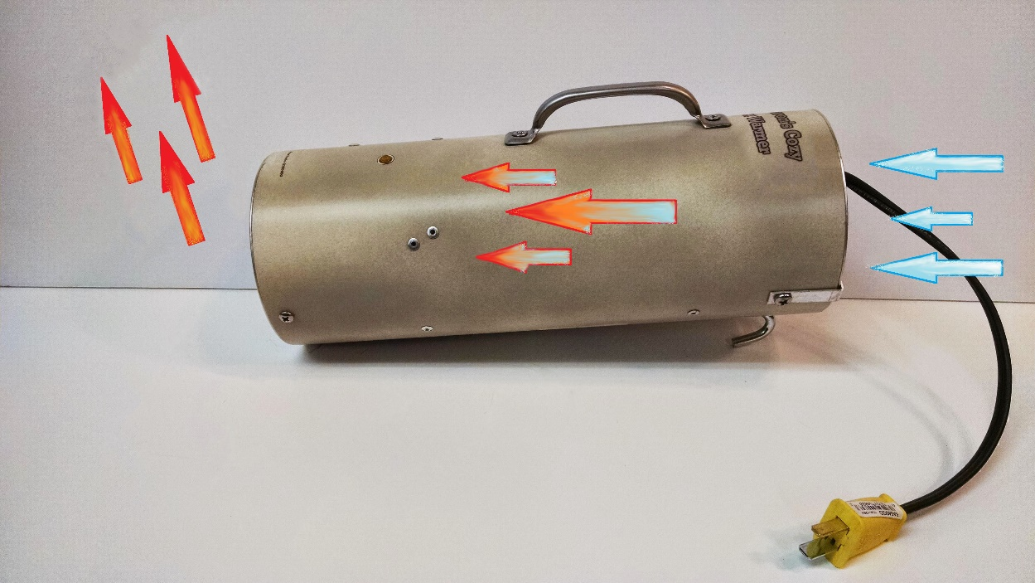

**Warranty:**

We at the KelsoStockwood Group Inc. guarantee “Sharon’s Cozy Pet Warmer” has been factory tested and is free of any and all factory defects when shipped to the user. If “Sharon’s Cozy Pet Warmer” is found to be defective due to manufacturing, it will be replaced at no cost to the user upon return of the device to the factory. Repairs to the pet warmer completed at the factory also reflect this guarantee.

Thank you for selecting “Sharon’s Cozy Pet Warmer” to keep the chill from a cold night! Warm Wishes!

All questions or concerns should be addressed to:

“Sharon’s Cozy Pet Warmer”

C/O The KelsoStockwood Group Inc.

Customer Service

P.O. Box 293

Interlachen, Florida 32148

kelsostockwood@aol.com